Name : Bhavika R. Parhate
Roll no : TB 54

FIFO:-

def findWaitingTime(processes, n, bt, wt):
wt[0] = 0
for i in range(1, n):
wt[i] = bt[i - 1] + wt[i - 1]
def findTurnAroundTime(processes, n, bt, wt, tat):
for i in range(n):
tat[i] = bt[i] + wt[i]
def findavgTime(processes, n, bt):
wt = [0] * n
tat = [0] * n
total_wt = 0
total_tat = 0
findWaitingTime(processes, n, bt, wt)
findTurnAroundTime(processes, n, bt, wt, tat)
print("Processes Burst time Waiting time Turn around time")
for i in range(n):
total_wt += wt[i]
total_tat += tat[i]
print(f" {i + 1}\t\t{bt[i]}\t {wt[i]}\t\t {tat[i]}")
print("Average waiting time = " + str(total_wt / n))
print("Average turn around time = " + str(total_tat / n))
if __name__ == "__main__":
# Process IDs
processes = [1, 2, 3]
n = len(processes)
# Burst time of all processes
burst_time = [10, 5, 8]

findavgTime(processes, n, burst_time)
Output :-
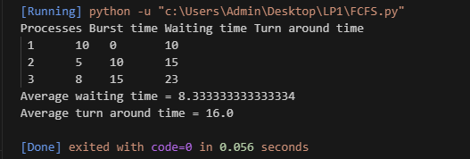

Name : Bhavika R. Parhate
Roll no : TB 54

Optimal :-
def optimal_page_replacement(pages, capacity):
page_faults = 0
page_frames = [-1] * capacity
for i in range(len(pages)):
if pages[i] not in page_frames:
if -1 in page_frames:
# If there is an empty frame, place the page in it
index = page_frames.index(-1)
page_frames[index] = pages[i]
else:
# Find the page that will not be used for the longest period in the future
future_occurrences = {page: float('inf') for page in page_frames}
for j in range(i + 1, len(pages)):
if pages[j] in future_occurrences:
future_occurrences[pages[j]] = j
# Replace the page that is not needed for the longest time
page_to_replace = max(future_occurrences, key=future_occurrences.get)
index = page_frames.index(page_to_replace)
page_frames[index] = pages[i]
print(f"Page {pages[i]} is loaded into memory.")
page_faults += 1
else:
print(f"Page {pages[i]} is already in memory.")
print(f"\nTotal Page Faults: {page_faults}")
if __name__ == "__main__":
# Example usage
page_references = [2, 3, 4, 2, 1, 3, 7, 5, 4, 3]
memory_capacity = 3

optimal_page_replacement(page_references, memory_capacity)
Output:-
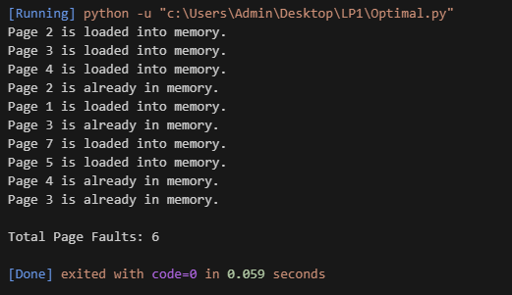

Name : Bhavika R. Parhate
Roll no : TB 54

LRU :-

from collections import OrderedDict
class LRUCache:
def __init__(self, capacity):
self.cache = OrderedDict()
self.capacity = capacity
def refer(self, page):
if page in self.cache:
# Move the page to the end to mark it as most recently used
self.cache.move_to_end(page)
else:
# Check if the cache is full
if len(self.cache) >= self.capacity:
# Remove the least recently used page (the first item in the ordered dictionary)
self.cache.popitem(last=False)
# Add the new page to the cache
self.cache[page] = None

def lru_page_replacement(pages, capacity):
lru_cache = LRUCache(capacity)
page_faults = 0
for page in pages:
if page not in lru_cache.cache:
print(f"Page {page} is loaded into memory.")
lru_cache.refer(page)
page_faults += 1
else:
print(f"Page {page} is already in memory.")

print(f"\nTotal Page Faults: {page_faults}")

if __name__ == "__main__":
# Example usage
page_references = [2, 3, 4, 2, 1, 3, 7, 5, 4, 3]
memory_capacity = 3

lru_page_replacement(page_references, memory_capacity)

Output :-
